THE DRAWING(S) AND THE INFORMATION CONTAINED HEREIN ARE THE PROPERTY OF WOOJIN INDUSTRIAL SYSTEMS CO., LTD. THEY SHALL NOT BE DISCLOSED, REPRODUCED OR USED, IN ANY MANNER WITHOUT THE PRIOR WRITTEN CONSENT OF WOOJIN INDUSTRIAL SYSTEMS CO., LTD. |  | LonWorks Communication  Interface Control Document  ( C/I Phase Shift Control)
DISTRIBUTION |  | R  E  V  I  S  I  O  N
 |  | R  E  V  I  S  I  O  N | 0 | May 15, 2012 |  | First Issued |  |  | D.B. LEE | D.S. JANG | B.J. JONE | E.K. LEE
 |  | R  E  V  I  S  I  O  N | No. | ISSUED  DATE |  | REVISION NOTE |  |  | DESIGNED | CHECKED | APPROVED | REVIEWED
 |  |  |  |  |  |  |  |  | ENGINEERING |  |  | PM
 |  | PM |  |  | REVIEWED |  | E.K. LEE |  | CUSTOMER :
 |  | ENGINEERING |  |  | APPROVED |  | B.J. JONE |  | HYUNDAI ROTEM COMPANY
 |  |  |  |  | CHECKED |  | D.S. JANG
 |  |  |  |  | DESIGNED |  | D.B. LEE |  | PROJECT :
 |  | ISSUED DATE |  |  | May 15, 2012 |  |  |  | DENVER RTD EAGLE P3  COMMUNICATION SYSTEM
 |  | ISSUED BY |  |  | R & D CENTER
 |  | PROJECT NO. |  |  | P2011-020
 |  | ORDER NO. |  |  | P110701149 |  |  |  | 
 |  | DOCUMENT NO. |  |  |  |  |  | REVISION
 |  | 42A-2012-0100 |  |  |  |  |  | 0
TOTAL |  |  |  |  |  |  |  | 0
REVISION RECORD
Rev. No. | PAGE | Details |  | Date
Rev. No. | PAGE | FROM | TO | Date
0 | - | First Issued |  | May 15, 2012
Table of Contents

1. LonWorks System Diagram 5
2. Contents to be mentioned additionally to CRA Communication. 6
2.1 Contents did not mentioned in Communication Document ( DDN-0432-0091) 6
2.2 Contents of MITSUBISHI ELECTRIC Document ( HCN-L6340-10) 7
3. LonWorks Interface Specification (FT5000 ← → MPU(TMS32OVC33) 8
3.1 Interface Method between MPU and FT5000(LonWorks). 8
3.2 FT 5000 Pin Definition. 8
3.3 SPI Interface Mode Definition. 9
3.4 LON / FT5000 Interface Protocol and Memory Structure. 10

Appendix A
Abbreviations
LIC | LonWorks Interface Control
CI-SDR | CI Send Data / Request.
CI-SD | CI Send Data.(Response of SDR)

LonWorks System Diagram

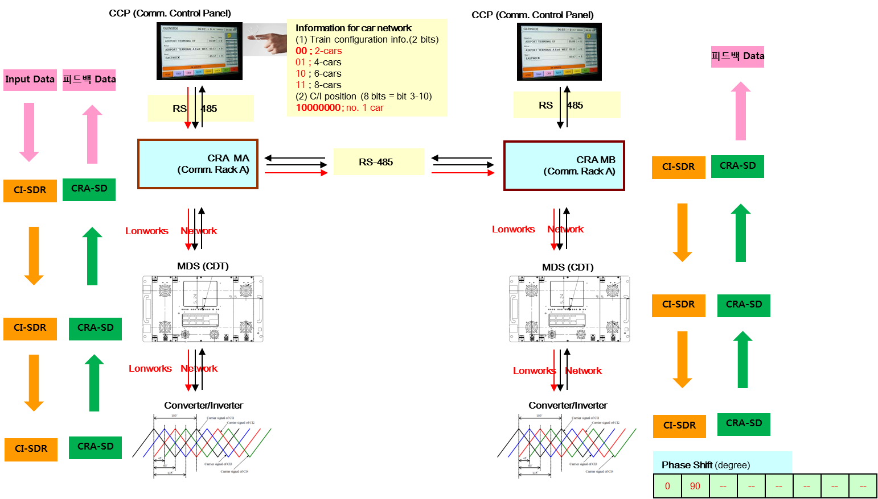

- CRA identifies the inputted Data from the CCP with 485 communication method.
- CRA transmits Train Configuration / C/I Position / Other C/I Fault Data to C/I by using the Lonworks Network.
- C/I feedbacks the received data to CRA by using the Lonworks Network.
- CRA transmits the feedback data received from the C/I to CCP by using the 485 Communication method.

Contents to be mentioned additionally to CRA Communication
: This section is to identify the contents which should be added for the interface between CRA ←→ MDS but we could not find this content in QT Communication document (DDN-0432-0091).
We need to discuss about the following contents related to MDS Interface type test (May 21st ) and need to perform each test followed by Woojin Engineers agreement. But Woojin will prepare the test reflecting the related contents at the most.
Additional functions to be identified
1) Train Configuration..
2) C/I position.
3) Other C/I fault condition.

Contents did not mentioned in Communication Document ( DDN-0432-0091)
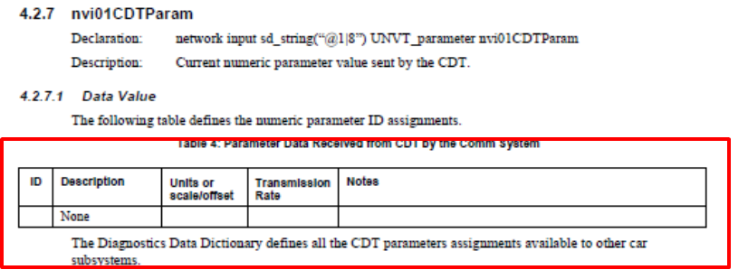

- There is no definition of additional CDT Parameter related to C/I Phase Shift Control.

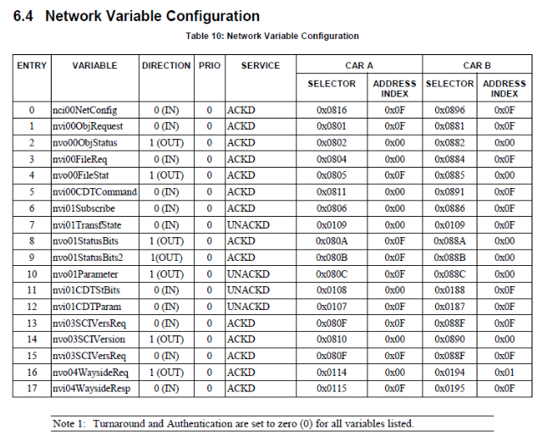

- Configuration Address designation is required when adding the CDT Parameter related to C/I Phase Shift Control.

Contents of MITSUBISHI ELECTRIC Document( HCN-L6340-10)
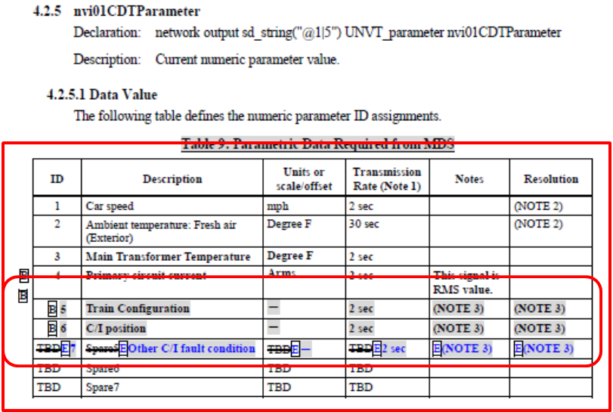
- Woojin Communications System related contents of MITSUBISHI ELECTRIC Document

LonWorks Interface Specification (FT5000 ← → MPU(TMS32OVC33)
: The contents of this section defines internal interface between FT5000 and MPU(TMS32OVC33) of Woojin LIC PCB.

Interface Method between MPU and FT5000 (LonWorks)
Communication Method | MASTER Unit | Clock Speed | Clock edge.
SPI Interface mode. | LON(FX5000) | 20MBPS | Rising edge.

FT 5000 Pin Definition
IO Pin Number | Contents
I/O_0 | DSP → Lon Interrupt
I/O_1 | LON → DSP Interrupt
I/O_2 | ×
I/O_3 | ×
I/O_4 | ×
I/O_5 | ×
I/O_6 | ×
I/O_7 | SELECT(CHIP SELECT)
I/O_8 | CLOCK(RISING EDGE)
I/O_9 | MISO(DSP → LON)
I/O_10 | MOSI(LON → DSP)

SPI Interface Mode Definition

SPI Transmission Method Structure
- Using from 1 byte to maximum 1024 byte is available and it will be accessed with consecutive data until the “SELECT” signal becomes ACTIVE.
- Transmits 1 byte of MSB(D7…..D0) when transmitting bit.
- Moves the data whenever the edge increases.
- MODE (0 : Write / 1 : Read)

- Transmission Data Structure
1BIT | 1BIT | 1BIT | 1BIT | 1BIT | 1BIT | 1BIT | 1BIT
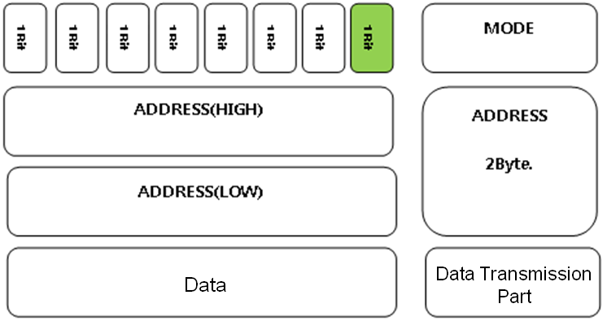

LON / FT5000 Interface Protocol and Memory Structure

Memory Structure
- Status Information
- 1~6 : Historical and Recent Data Interface Domain
- 7 : General Information Data Interface Domain
- 0 or 8~255 are not being used.

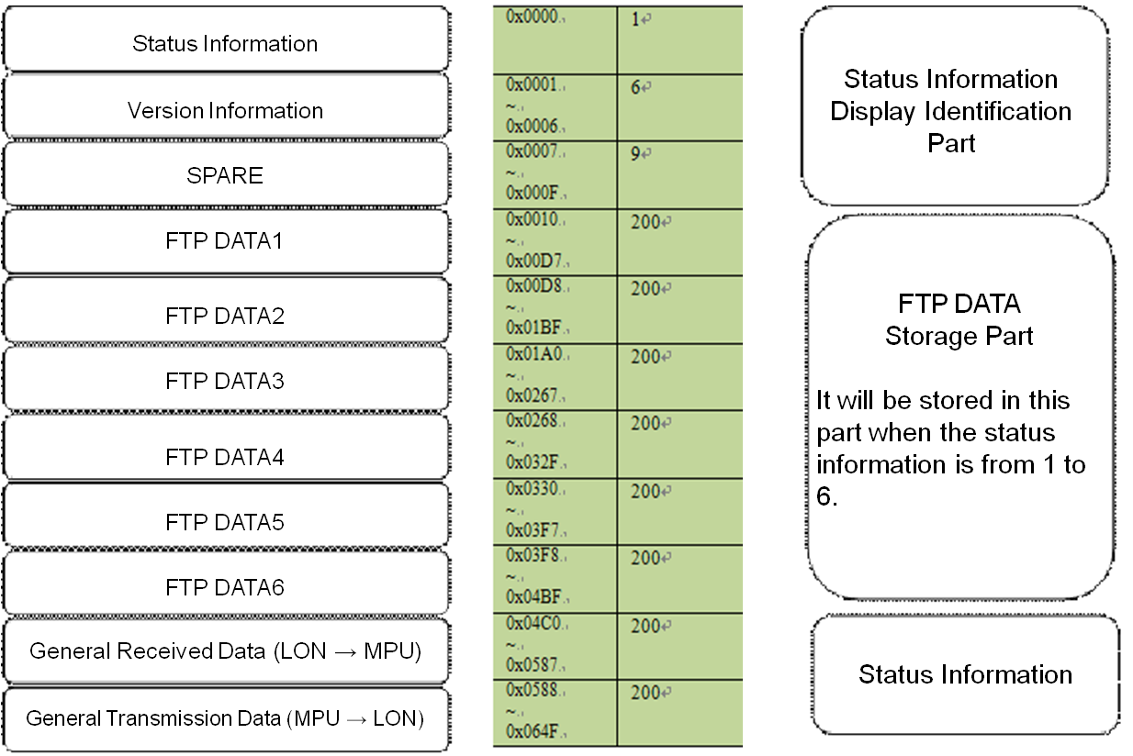

Version Information Structure

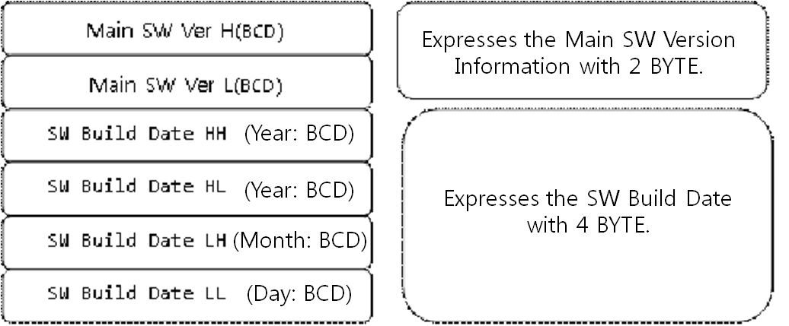
1BYTE
1BYTE
1BYTE
1BYTE
1 BYTE
1BYTE

Protocol Structure

Protocol Basic Structure

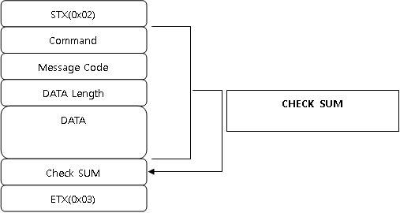
1BYTE
1BYTE
1BYTE
1BYTE
N BYTE
1BYTE
1BYTE

Command Code .
: The part which is relevant to the QT Document (DDN-0432-0091) 4.4 Wayside Data Transfer Object.
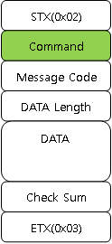 | CODE | Contents
 | 0x01 | Wayside On Notification | MPU(TMS320VC33) to FT5000
 | 0x02 | Wayside On Identification | FT5000to MPU(TMS320VC33)
 | 0x05 | FT3150 FTP Transmission | FT5000to MPU(TMS320VC33)
 | 0x06 | FT3150 FTP Transmission End | FT5000to MPU(TMS320VC33)
 | 0x07 | Car Number Transmission | FT5000to MPU(TMS320VC33)
 | 0x08 | Time Information Request | FT5000to MPU(TMS320VC33)
 | 0x09 | Time Information Transmission | MPU(TMS320VC33) to FT5000
 | 0x0A | Comm Status Request | FT5000to MPU(TMS320VC33)
 | 0x0B | Comm Status Transmission | MPU(TMS320VC33) to FT5000
 | 0x0C | Version Request | FT5000to MPU(TMS320VC33)
 | 0x0D | Version Response | MPU(TMS320VC33) to FT5000
 | 0x0E | DOOR Status | FT5000to MPU(TMS320VC33)
 | 0x0F | Train Configuration | MPU(TMS320VC33) to FT5000
 | 0x10 | C/I Position | MPU(TMS320VC33) to FT5000
 | 0x11 | Other C/I Fault | FT5000 to MPU(TMS320VC33)
 | 0x12 | CRA ADDRESS | MPU(TMS320VC33) to FT5000

Protocol Detailed Structure

Wayside On Notification (MPU → LonWorks)
: The part which is relevant to the QT Document (DDN-0432-0091) 4.4 Wayside Data Transfer Object.
STX | 0x02 | 1
Command Code | 0x01 | 1
Message Code | 0x00 | 1
Data Length | 0x06 | 1
DATA | Station (Recent) : 0x01, Depot (Historical) : 0x02 | 1
DATA | ‘A' : Collect from A car, 'B' : Collect from B car | 1
DATA | From 0 Hour 0 Minute 0 Second (HH,HL,LH,LL) of January 1st, 2000 | 4
CheckSum | CheckSum Code | 1
ETX | 0x03 | 1

Wayside On Identification ( LonWorks → MPU )
: The part which is relevant to the QT Document (DDN-0432-0091) 4.4 Wayside Data Transfer Object.
STX | 0x02 | 1
Command Code | 0x02 | 1
Message Code | 0x00 | 1
Data Length | 0x00 | 1
DATA | - | -
CheckSum | CheckSum Code | 1
ETX | 0x03 | 1

During the FTP Protocol Transmission (LonWorks → MPU)
: The part which is relevant to the QT Document (DDN-0432-0091) 4.4 Wayside Data Transfer Object.
STX | 0x02 | 1
Command Code | 0x05 | 1
Message Code | Varies from 1 to 6 (Expressed the FTP transmission block) | 1
Data Length | 1~131 | 1
DATA | Car type : 'A' or 'B' | 1
DATA | Data | 0~130
CheckSum | CheckSum Code | 1
ETX | 0x03 | 1

FTP Protocol Transmission End ( LonWorks → MPU )
: The part which is relevant to the QT Document (DDN-0432-0091) 4.4 Wayside Data Transfer Object.
STX | 0x02 | 1
Command Code | 0x06 | 1
Message Code | 0x00 | 1
Data Length | 0x00 | 1
DATA | - | -
CheckSum | CheckSum Code | 1
ETX | 0x03 | 1

Reading Car Number (LonWorks → MPU)
- Denver Vehicle number Starts from “4001”.
- “A” type vehicle gets the odd number (ex : 4001) , “B” type vehicle gets the even number (ex : 4002).

STX | 0x02 |  | 1
Command Code | 0x07 |  | 1
Message Code | 0x00 |  | 1
Data Length | 0x02 |  | 1
DATA | Car Number Binary(HH) | Car Number Binary(HL) | 1
DATA | Car Number Binary(LH) | Car Number Binary(LL) | 1
CheckSum | CheckSum Code |  | 1
ETX | 0x03 |  | 1

Time Information Request (LonWorks → MPU)
: The part which is relevant to the QT Document (DDN-0432-0091) 4.1 Node Object – Object.
STX | 0x02 | 1
Command Code | 0x08 | 1
Message Code | 0x00 | 1
Data Length | 0x00 | 1
DATA | - | -
CheckSum | CheckSum Code | 1
ETX | 0x03 | 1

Time Information Response (MPU → LonWorks)
: The part which is relevant to the QT Document (DDN-0432-0091) 4.1 Node Object.
STX | 0x02 | 1
Command Code | 0x09 | 1
Message Code | 0x00 | 1
Data Length | 0x06 | 1
DATA | Year (BCD) | 6
DATA | Month (BCD) | 6
DATA | Day (BCD) | 6
DATA | Hour (BCD) | 6
DATA | Minute (BCD) | 6
DATA | Second (BCD) | 6
CheckSum | CheckSum Code | 1
ETX | 0x03 | 1

Comm Status Information Request (LonWorks → MPU)
: The part which is relevant to the QT Document (DDN-0432-0091) 4.2 Monitoring Object.
STX | 0x02 | 1
Command Code | 0x0A | 1
Message Code | 0x00 | 1
Data Length | 0x01 | 1
DATA | 1 (CDT←→ LIC are one-to-one all the time.) | 1
CheckSum | CheckSum Code | 1
ETX | 0x03 | 1

Comm Status Information Transmission (MPU → LonWorks )
: The part which is relevant to the QT Document (DDN-0432-0091) 4.2 Monitoring Object.
STX | 0x02 |  |  |  |  |  |  |  | 1
Command Code | 0x0B |  |  |  |  |  |  |  | 1
Message Code | 0x00 |  |  |  |  |  |  |  | 1
Data Length | 0x05 |  |  |  |  |  |  |  | 1
DATA | CCP1 | VOIPC | GPS | WLR | PAC | LIC | VTX | CNCS | 5
DATA | Spare | FDI | PII1 | PII2 | SDI1 | SDI2 | SDI3 | SDI4 | 5
DATA | Spare | Spare | Spare | PID1-1 | PID1-2 | PID1-3 | PID1-4 | PID2-1 | 5
DATA | DPH1 | Spare | Spare | DPO1 | Spare | Spare | PEI2 | PEI1 | 5
CheckSum | CheckSum Code |  |  |  |  |  |  |  | 1
ETX | 0x03 |  |  |  |  |  |  |  | 1

Version Request (LonWorks → MPU )
: The part which is relevant to the QT Document (DDN-0432-0091) 4.3 SCI Version Object.
STX | 0x02 | 1
Command Code | 0x0C | 1
Message Code | 0x00 | 1
Data Length | 0x01 | 1
DATA | Unit Index (Counts as many as the unit amount. Total 26EA) | 1
CheckSum | CheckSum Code | 1
ETX | 0x03 | 1

Version Response (MPU → LonWorks )
: The part which is relevant to the QT Document (DDN-0432-0091) 4.3 SCI Version Object.
STX | 0x02 | 1
Command Code | 0x0D | 1
Message Code | 2 : Firmware,  0 : Outputs Not used and does not output Version and Date.  6 : Stop Version Transmission (LIC -> CDT) | 1
Data Length | 0x07 | 1
DATA | Version Index Number | 31
DATA | Type | 31
DATA | Name[9] : char | 31
DATA | Version[9] : char | 31
DATA | Build_date[11]:char | 31
CheckSum | CheckSum Code | 1
ETX | 0x03 | 1

DOOR Status (LonWorks → MPU )
: The part which is relevant to the QT Document (DDN-0432-0091) 4.2 Monitoring Object.
STX | 0x02 |  |  |  |  |  |  |  | 1
Command Code | 0x0E |  |  |  |  |  |  |  | 1
Message Code | 0x00 |  |  |  |  |  |  |  | 1
Data Length | 0x01 |  |  |  |  |  |  |  | 1
DATA |  | - | - | - | All Doors Closed |  | Traction  command | Active  Cab | 1
CheckSum | CheckSum Code |  |  |  |  |  |  |  | 1
ETX | 0x03 |  |  |  |  |  |  |  | 1

Train Configuration. (MPU ← → LonWorks )

STX | 0x02 | 1
Command Code | 0x0F | 1
Message Code | MPU → LonWorks : 0x10  LonWorks → MPU : 0x11 | 1
Data Length | 0x02 | 1
DATA | 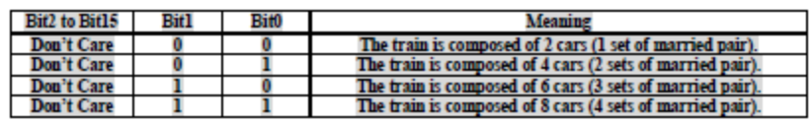 | 1
CheckSum | CheckSum Code | 1
ETX | 0x03 | 1
- It first transmits the data from MPU to LonWorks when starting the boot up.
- LON transmits the received data to CDT.
- LonWorks changes only the Message Code and re-transmit to MPU as the response of the received data.

C/I Position. (MPU ← → LonWorks )

STX | 0x02 | 1
Command Code | 0x10 | 1
Message Code | MPU → LonWorks : 0x10  LonWorks → MPU : 0x11 | 1
Data Length | 0x02 | 1
DATA | 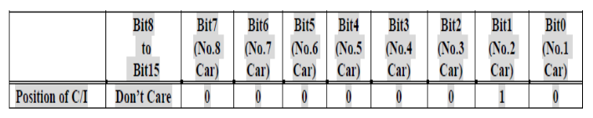  1 : Displays relevant vehicle location/ 0 : Displays irrelevant vehicle location | 1
CheckSum | CheckSum Code | 1
ETX | 0x03 | 1

- It first transmits the data from MPU to LonWorks when starting the boot up.
- LON transmits the received data to CDT.
- LonWorks changes only the Message Code and re-transmit to MPU as the response of the received data.

Other C/I Fault (LonWorks → MPU )

STX | 0x02 | 1
Command Code | 0x11 | 1
Message Code | MPU → LonWorks : 0x10  LonWorks → MPU : 0x11 | 1
Data Length | 0x02 | 1
DATA | 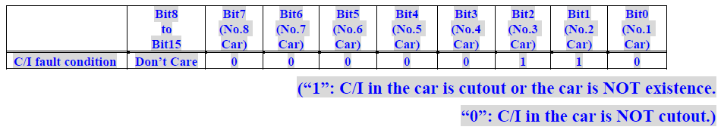  1 : Displays the location of vehicle in failure or information of irrelevant vehicle  0 : Displays the location of normal operating vehicle | 1
CheckSum | CheckSum Code | 1
ETX | 0x03 | 1

- The vehicle which C/I failure occurred transmits the failure information to CDT.
- CDT transmits failure information to LIC PCB.
- LON which received the failure information transmits the information to MPU.
- MPU notifies the failure information to other vehicles by using the main communication.
- MPU of other vehicle transmits the data which received by the main communication to the LON.
- LON which received the transmission transmits the failure information to CDT.

- First transmit the data if it is a C/I failed vehicle. If not, receives the failure data.

CAR ADDRESS (MPU → LonWorks )

STX | 0x02 | 1
Command Code | 0x12 | 1
Message Code | 0x00 | 1
Data Length | 0x01 | 1
DATA | “A” , “B” ASCII Code Transmission (0x41,0x42)  Transmits CRA ADDRESS Information | 1
CheckSum | CheckSum Code | 1
ETX | 0x03 | 1

- MPU transmits its ADDRESS to LonWorks when starting the boot up.
- ASCII Code is used for the transmission code and it will be transmitted to “A” or “B”.

CRA-MDS-C/I Interface Test Procedures.

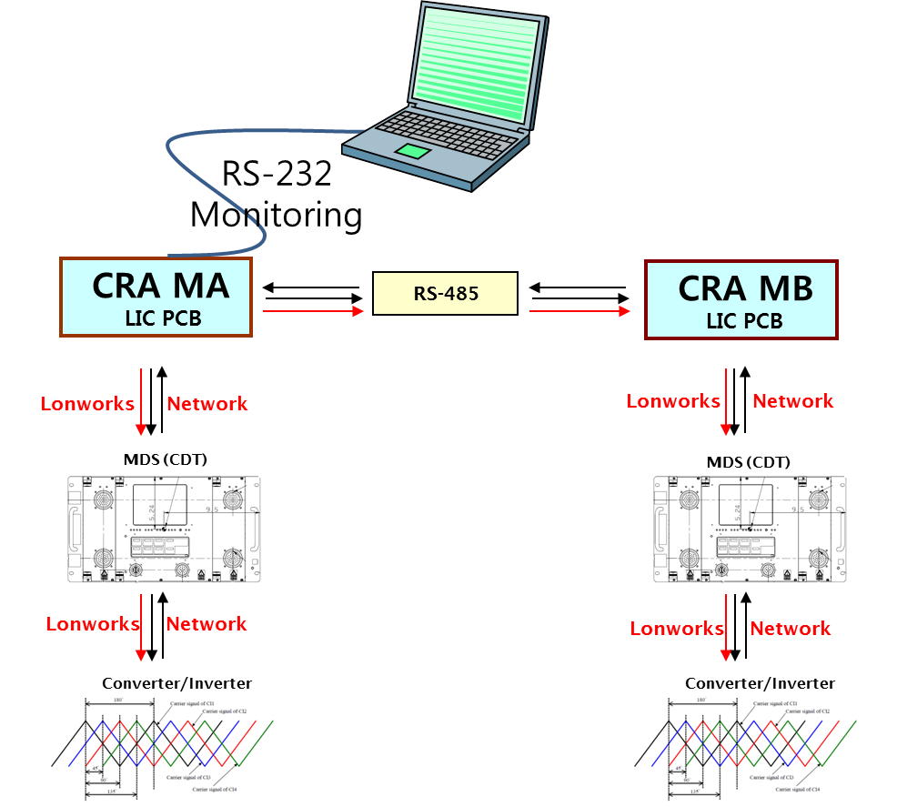

Train Configuration
: 3.4.4.7 프로토콜을 노트북에서 RS 232로 CRA MA (LIC PCB)로 전송한다.
CRA MA전달 받은 데이터를 RS-485를 이용하여 MB로 데이터를 전달 한다.
MA(LIC)/ MB(LIC)는 CDT로 데이터를 전송 한다.

항목. | 내용. | 비고.
1 | CRA MA LIC PC → CDT로 데이터 전달 하였는가? | Train Configuration 프로토콜 데이터 부분을 QT에서 정의한 문서에 의거  LIC → CDT로 전달 하는지 확인.
2 | CDT → C/I 로 데이터 전달 하였는가? | CDT는 LIC로부터 수신한 데이터(Train Configuration 정보)를 C/I 로 전달 해야 한다.
3 | CRA MB LIC PC → CDT로 데이터 전달 하였는가? | Train Configuration 프로토콜 데이터 부분을 QT에서 정의한 문서에 의거  LIC → CDT로 전달 하는지 확인.
4 | CDT → C/I 로 데이터 전달 하였는가? | CDT는 LIC로부터 수신한 데이터(Train Configuration 정보)를 C/I 로 전달 해야 한다.

C/I Position.
: 3.4.4.8 프로토콜을 노트북에서 RS 232로 CRA MA (LIC PCB)로 전송한다.
CRA MA전달 받은 데이터를 RS-485를 이용하여 MB로 데이터를 전달 한다.
MA(LIC)/ MB(LIC)는 CDT로 데이터를 전송 한다.
- MA/MB는 각각 다른 정보를 수신한다.(자신의 위치 정보 데이터를 수신)
항목. | 내용. | 비고.
1 | CRA MA LIC PC → CDT로 데이터 전달 하였는가? | C/I Position프로토콜 데이터 부분을 QT에서 정의한 문서에 의거  LIC → CDT로 전달 하는지 확인.
2 | CDT → C/I 로 데이터 전달 하였는가? | CDT는 LIC로부터 수신한 데이터(C/I Position정보)를 C/I 로 전달 해야 한다.
3 | CRA MB LIC PC → CDT로 데이터 전달 하였는가? | C/I Position프로토콜 데이터 부분을 QT에서 정의한 문서에 의거  LIC → CDT로 전달 하는지 확인.
4 | CDT → C/I 로 데이터 전달 하였는가? | CDT는 LIC로부터 수신한 데이터(C/I Position정보)를 C/I 로 전달 해야 한다.

Other C/I Fault.
: CRA MA에 C/I 가 고장이 발생 하고, CDT → MA(LIC PCB)로부터 고장 정보를 수신한다.
CRA MA는 전달 받은 데이터를 RS-485를 이용하여 MB로 데이터를 전달 한다.
고장 정보를 수신한 MB(LIC PCB)는 고장 정보를 CDT 로 전달 한다.
- MA/MB는 같은 고장 정보를 공유한다.
항목. | 내용. | 비고.
1 | C/I 는 고장정보를 CDT로 전달 하였는가? | C/I Fault 정보가 QT에서 정의한 문서에 의거C/I → CDT로 전달 하는지 확인.
2 | CDT → LIC 로 데이터 전달 하였는가? | CDT는 C/I 로부터 수신한 데이터(C/I Fault정보)를 LIC 로 전달 해야 한다.
3 | CRA MB LIC PC → CDT로 데이터 전달 하였는가? | MA(LIC PCB) 는 수신한 고장 정보를 RS 485를 이용하여 MB(LIC PCB)로 전달 한다. 전달 받은  C/I Fault 데이터를QT에서 정의한 문서에 의거LIC → CDT로 전달 하는지 확인.
4 | CDT → C/I 로 데이터 전달 하였는가? | CDT는 LIC로부터 수신한 데이터(C/I Fault정보)를 C/I 로 전달 해야 한다.

